XML Injection
# Source: Chatgpt (GPT-5-Mini) at [1/20/2026]
XML Injection is a security vulnerability where an attacker manipulates or injects malicious XML data into an application that processes XML input. By altering the XML structure or content, the attacker can change how the application interprets the data, potentially causing:
- Unexpected behavior
- Application errors
- Unauthorized data access
- Bypass of security controls

How It Happens
# Source: Chatgpt (GPT-5-Mini) at [1/20/2026]
If an application accepts XML input (for example, via web services or APIs) and does not properly validate or sanitize this XML, an attacker can inject extra XML elements, attributes, or malformed XML to exploit the system.

Example
# Source: Chatgpt (GPT-5-Mini) at [1/20/2026]
Suppose an application expects this XML:
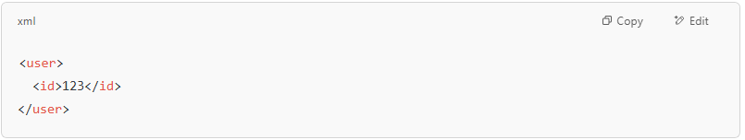
<user>
<id>123</id>
</user>

An attacker might send:
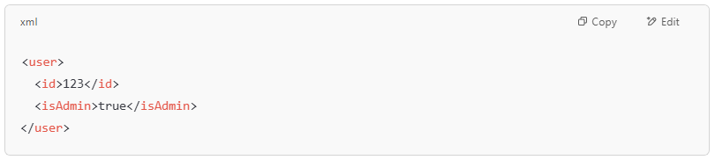
<user>
<id>123</id>
<isAdmin>true</isAdmin>
</user>

If the application trusts this input without validation, it might mistakenly grant admin privileges.

Risks of XML Injection
# Source: Chatgpt (GPT-5-Mini) at [1/20/2026]
- Changing application logic by injecting extra nodes or attributes
- Causing XML parsing errors (denial of service)
- Bypassing authentication or authorization
- Extracting or modifying data unexpectedly

How to Prevent XML Injection
# Source: Chatgpt (GPT-5-Mini) at [1/20/2026]
- Validate XML input against a strict schema (XSD)
- Sanitize input to remove unexpected tags or attributes
- Use secure XML parsers with safe configuration (disable external entity processing)
- Avoid building XML by string concatenation with user input
- Apply least privilege to the services processing XML

